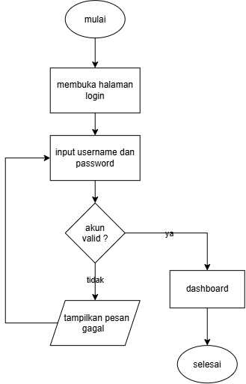
Gambar 1 Activity Diagram Login

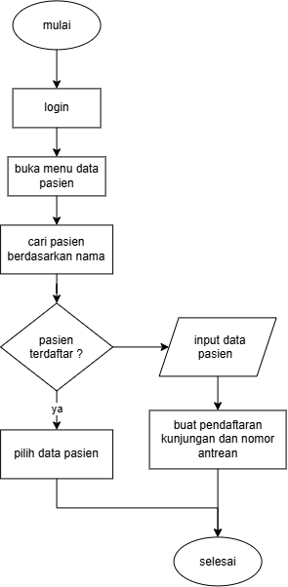
Gambar 2 Activity Diagram Pendaftaran Pasien

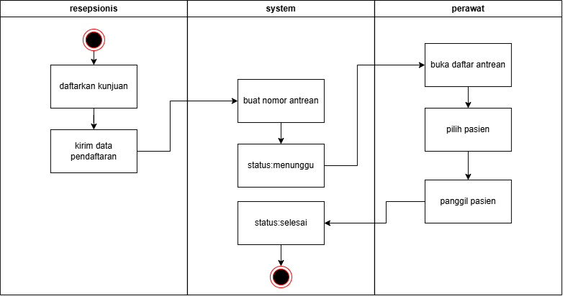
Gambar 3 Activity Diagram Proses Antrean

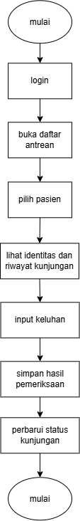
Gambar 4 Activity Diagram Pemeriksaan Pasien

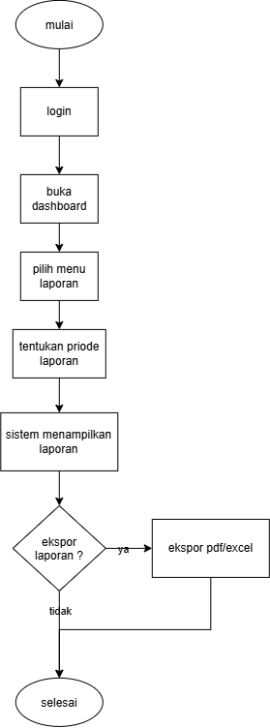
Gambar 5 Activity Diagram Owner

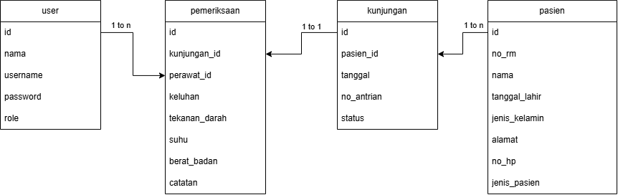
Gambar 6 ERD

